AI ASSISTED CODING LAB

ASSIGNMENT 7.4

LAB NAME : AI Assisted Coding

LAB NUMBER :7.4

ROLL NUMBER :2503a51l05

BATCH NO :24BTCAICSB19

NAME OF STUDENT : N .SATYA SRI CHARAN

**TASK 1:** Introduce a buggy Python function that calculates the factorial of a number using recursion. Use Copilot or Cursor AI to detect and fix the logical or syntax errors.

**PROMPT: Buggy version**

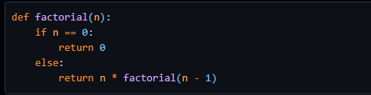

**Fixed version:**

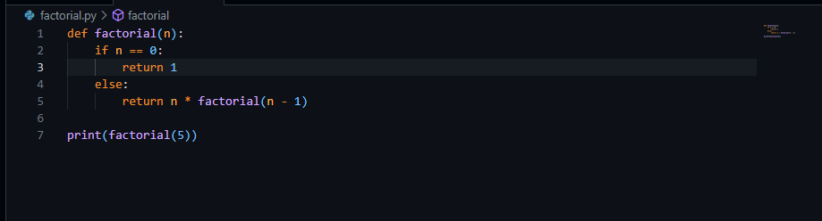

**OUTPUT:**

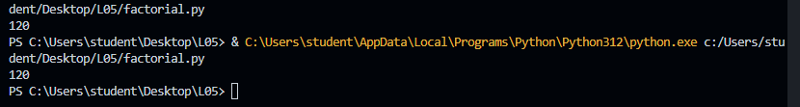

**TASK 2:** Provide a list sorting function that fails due to a type error (e.g., sorting list with mixed integers and strings). Prompt AI to detect the issue and fix the code for consistent sorting.

**PROMPT :**

**Error version**

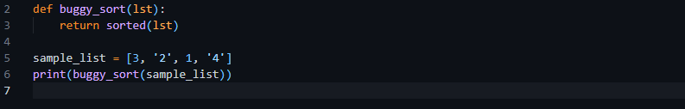

**Fix the error**

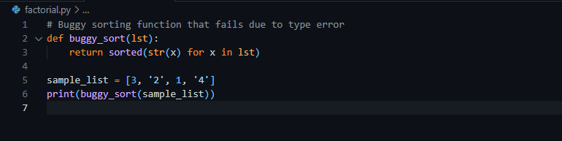

**OUTPUT:**



**TASK 3:** Write a Python snippet for file handling that opens a file but forgets to close it. Ask Copilot or Cursor AI to improve it using the best practice (e.g., with open() block).

**PROMPT:**

**BUGGY VERSIONS**

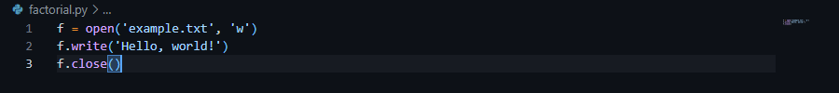

**FIX THE BUGGY**

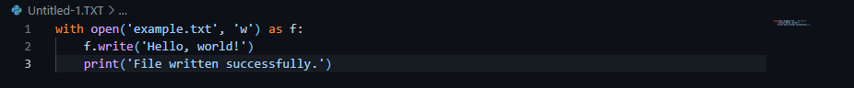

**OUTPUT:**



**TASK 4:** Provide a piece of code with a ZeroDivisionError inside a loop. Ask AI to add error handling using try-except and continue execution safely.

**PROMPT:**

**ERROR VERSIONS**



**FIX THE ERROR VERSION**

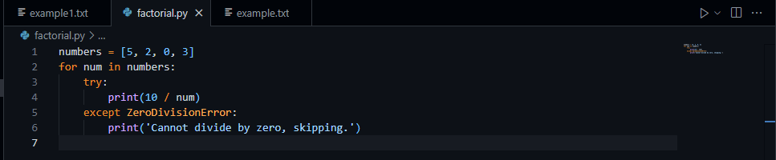

**OUTPUT:**

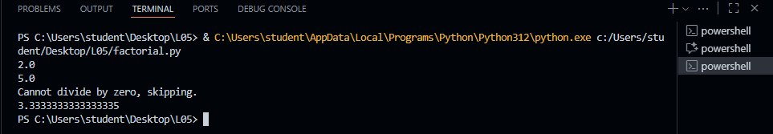

**TASK 5:** Include a buggy class definition with incorrect __init__ parameters or attribute references. Ask AI to analyze and correct the constructor and attribute usage.

**PROMPT:**

**ERROR VERSION**

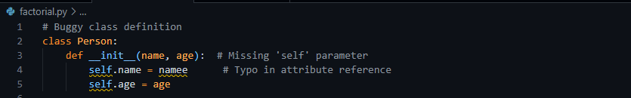

**FIX THE ERROR**

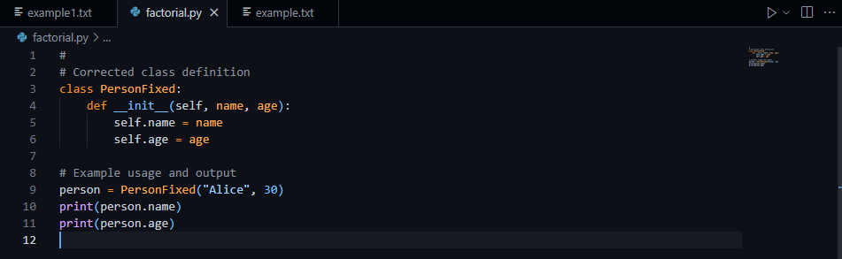

**OUTPUT**

